POC 1 - Implementation

Mongo Collections

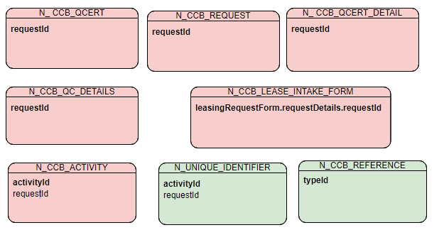

Collection Structure: N_CCB_REQUEST
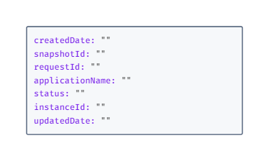

Collection Structure: N_CCB_ACTIVITY
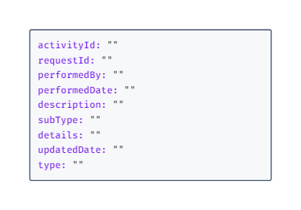

Collection Structure: N_CCB_LEASE_INTAKE_FORM
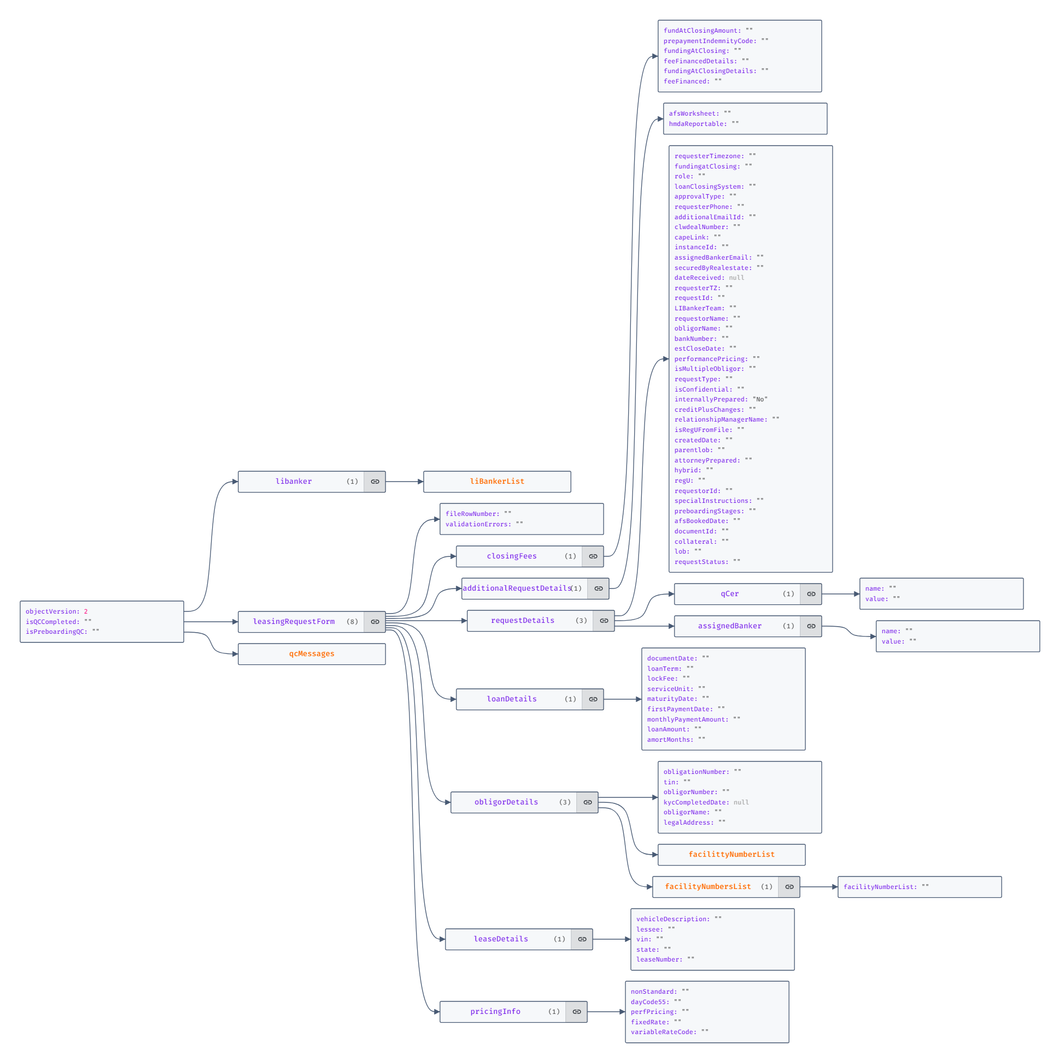

Collection Structure: N_CCB_QCERT
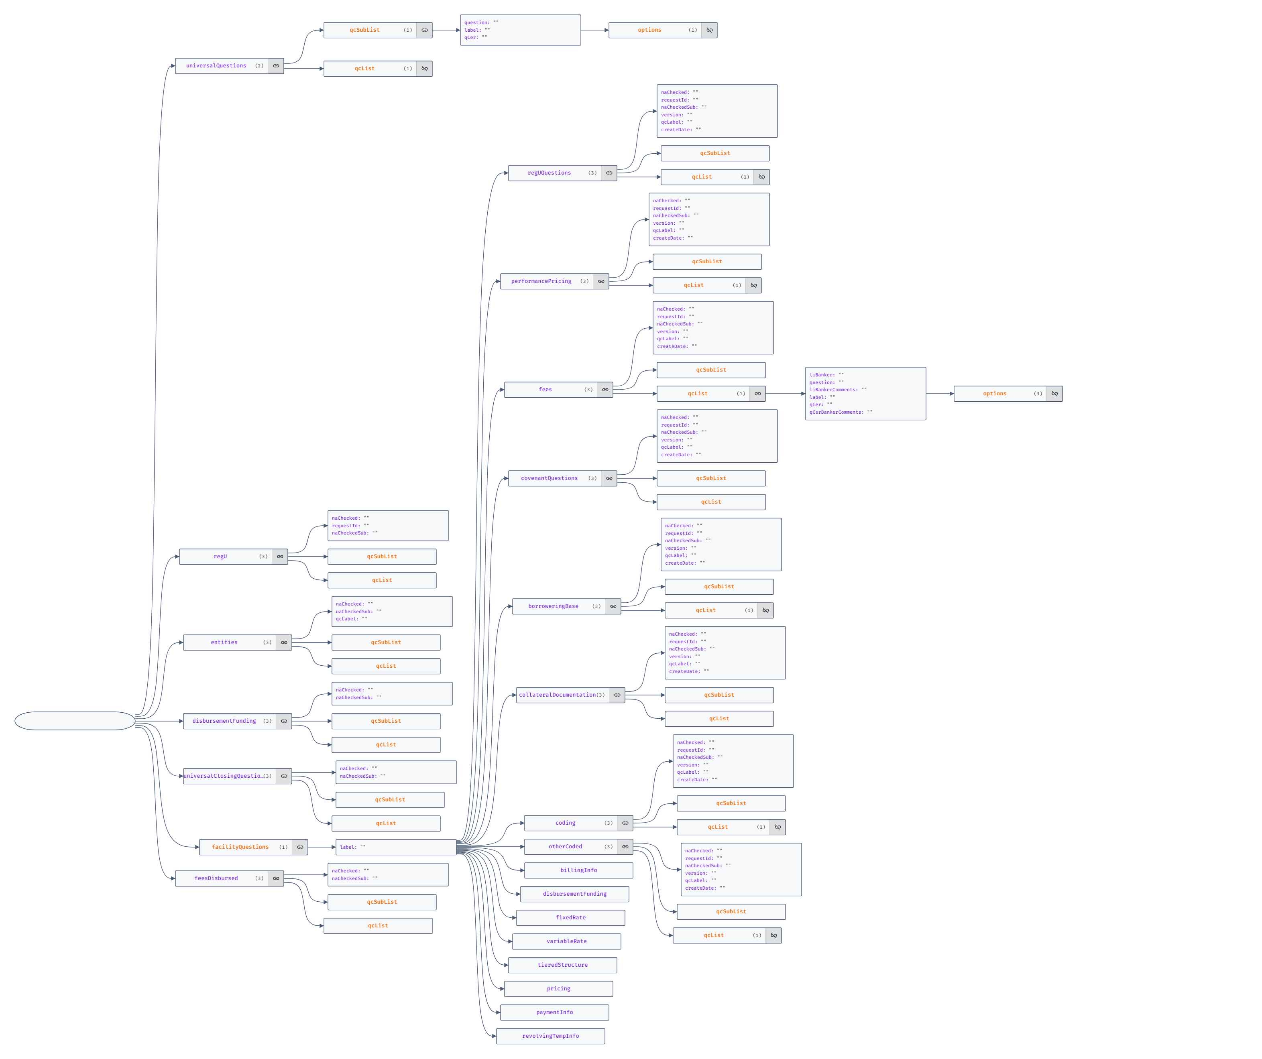

Collection Structure: N_CCB_QC_DETAILS
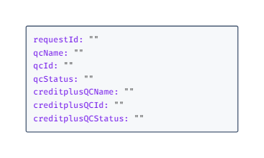

Collection Structure: N_ CCB_QCERT_DETAIL
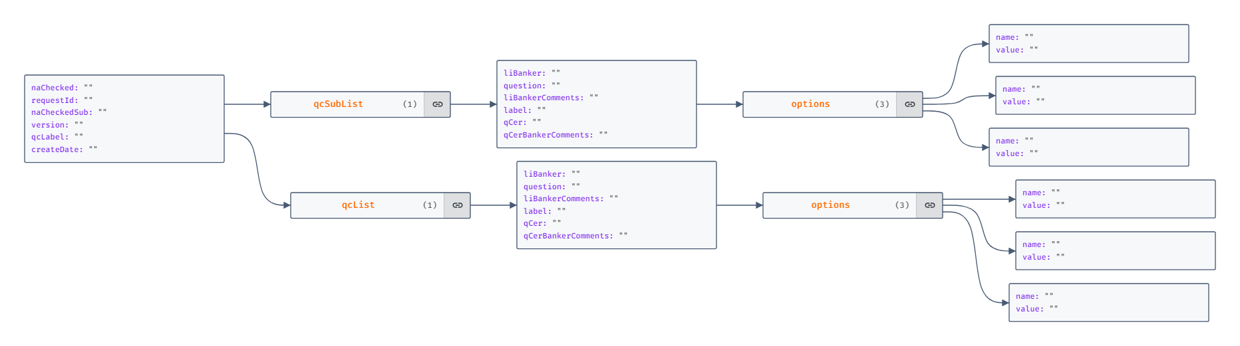

Collection Structure: N_CCB_REFERENCE
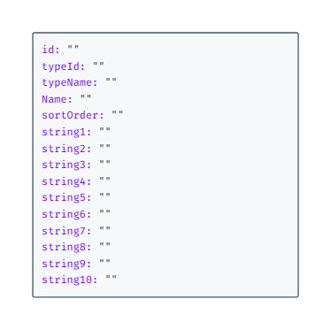

Collection Structure: N_ UNIQUE_IDENTIFIER
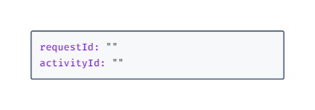

JSONS
Index for most of the Collection was based on requestId, the details are provided below.
Native Collection | Indexes
N_CCB_REQUEST | RequestId & Status
N_CCB_LEASE_INTAKE_FORM | leasingRequestForm.requestDetails.requestId
N_ CCB_QCERT | requestId
N_CCB_ACTIVITY | RequestId, Type  ActivityId
N_CCB_REFERENCE | typeId, String10
N_CCB_QC_DETAILS | RequestId
N_ CCB_QCERT_DETAIL | None
N_UNIQUE_IDENTIFIER | None

POC 2:
Collection Sample
{
"seqId": 1,
"EEID": "PERF0012",
"fullName": "Test Full Name 123",
"jobTitle": "jobTitle",
"department": "Dep1",
"businessUnit": "BU",
"gender": "M",
"age": 25,
"hireDate": "19/09/2021",
"annualSalary": 12121,
"bonus": 213,
"country": "USA",
"city": "New York",
"dob": "19/09/1999",
"clients": [
{
"cId": 12,
"refEId": 0,
"cName": "cname",
"domain": "domain",
"projects": [
{
"pId": 2500,
"refCId": 0,
"pName": "asdf",
"staffCount": 0,
"milestones": [
{
"mId": 125,
"refPId": 0,
"mName": "MilestoneName",
"targetDate": "2023-02-07"
}
]
}
]
}
]
}

Index
- GENDER
- CITY
- CLIENTS.DOMAIN
- CLIENTS.PROJECTS.STAFFCOUNT (desc order)
- CLIENTS.PROJECTS.LOCATION
- CLIENTS.PROJECTS.STARTDATE
- CLIENTS.PROJECTS.MILESTONES.MNAME
- CLIENTS.PROJECTS.MILESTONES.TARGETDATE

